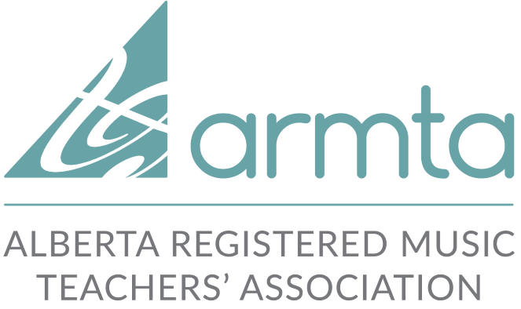
Community Service Award

Student Application Form

Student’s Name: _______________________________________________

Certificate applying for:
- Bronze 10 hours
- Silver 35 hours (25 more than Bronze)
- Gold 60 hours (25 more than Silver)

Teacher's Name: _________________________________________

Teacher’s Email: _________________________________________

Branch: _________________________________________

Teacher's Signature: _________________________________________________

Record Sheet
Students should include the time volunteering at the location but not travel time.

DATE | RECIPIENT OF SERVICE | DESCRIPTION OF SERVICE | HOURS | SIGNATURE OF RECIPIENT

Please return completed forms to:
Marlaine Osgood, ARMTA Community Service Award
410 Walker Rd NW, Edmonton, AB T5T 2X2
osgoodmg@gmail.com

