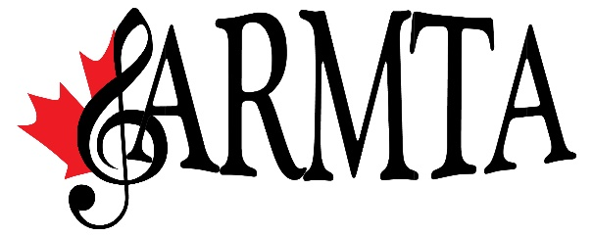

MISSION STATEMENT: To enhance the quality of life by promoting the love and knowledge of music through professional music teaching and service in the community and to provide cultural events of a high standard.

ARMTA works to educate and encourage teachers and students alike in their musical pursuits through programs such as the music writing competition, Canada Music Week activities, concerto competitions and a wide assortment of concerts and workshops.

ARMTA is also committed to providing continuing education opportunities for those in remote and/ rural areas.

ARMTA is also involved in local and provincial music festivals and offers a number of scholarships.

Encouraging our youth to achieve their highest musical potential is central to the heart of ARMTA.

For more information, please visit:
www.armta.ca

[insert other sponsor’s logos or acknowledgements]

Special thanks to [name] for organizing the event.

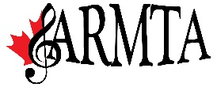
Alberta Registered Music Teachers’ Association
Provincial Continuing Education
and
[insert branch logo]
[Branch Name]

present

[Masterclass/Workshop/Recital Title]

with

[Name of the Clinician]

[insert photo of the clinician]

[Date]
[Time]
[Location]

[Name of Participant]
[Title of piece] [Composer]

[Name of Participant]
[Title of piece] [Composer]

[Name of the Clinician]
[short bio]

