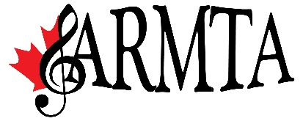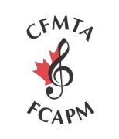
Photographs and Video consent, waiver, indemnity and release for the Alberta Registered Music Teachers’ Association (ARMTA) and for Canadian Federation of Music Teachers Association (CFMTA)
The undersigned grant the right to publish and use any photographs and to exhibit audio or video in which their works appear for the purposes of ARMTA and CFMTA archives, marketing, publicity and public relations projects. In signing below, I guarantee that any material recorded during this event will not be used in any commercial endeavor whatsoever without the written permission of ARMTA and CFMTA and all persons involved in the performance/recording.
Date:
Name (Printed) Signature
____________________________________________________________________________________
Address Phone #
____________________________________________________________________________________
Parent/Guardian Name (printed) if participant is under age 18 Signature
____________________________________________________________________________________

Date:
Name (Printed) Signature
____________________________________________________________________________________
Address Phone #
____________________________________________________________________________________
Parent/Guardian Name (printed) if participant is under age 18 Signature
____________________________________________________________________________________

